Software engineering for AI

techniques

Lab assignment

NAME: Y.V.SATWIK

REG NO: 192110684

DAY: 1

1. Draw a USE-CASE diagram for Online Voting System using CASE tools

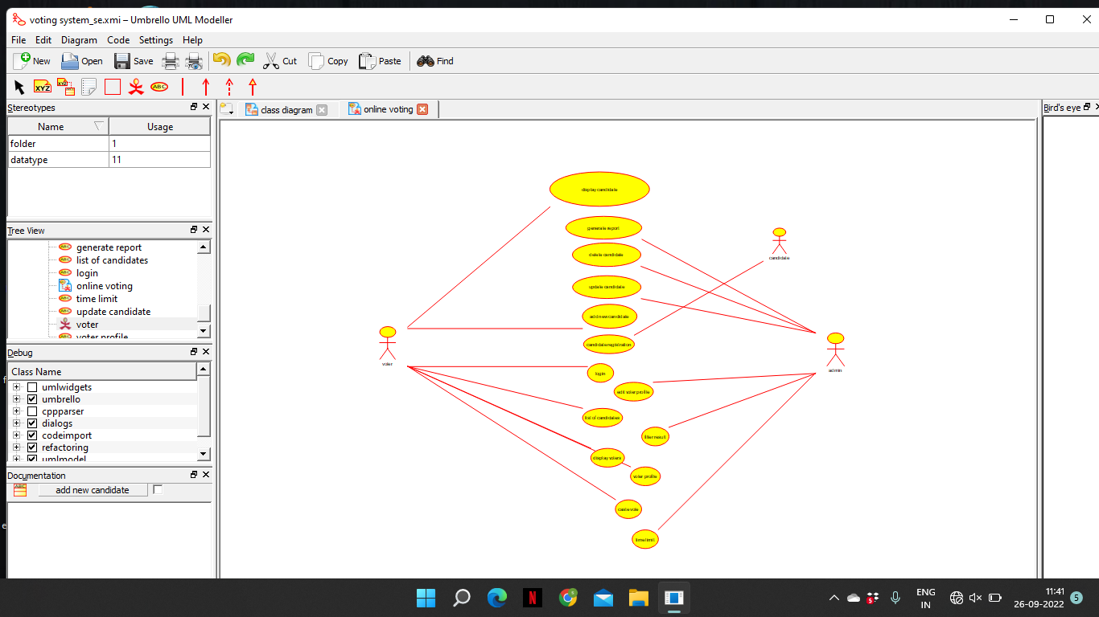

2.Draw a USE-CASE diagram for Library Management System using CASE tools.

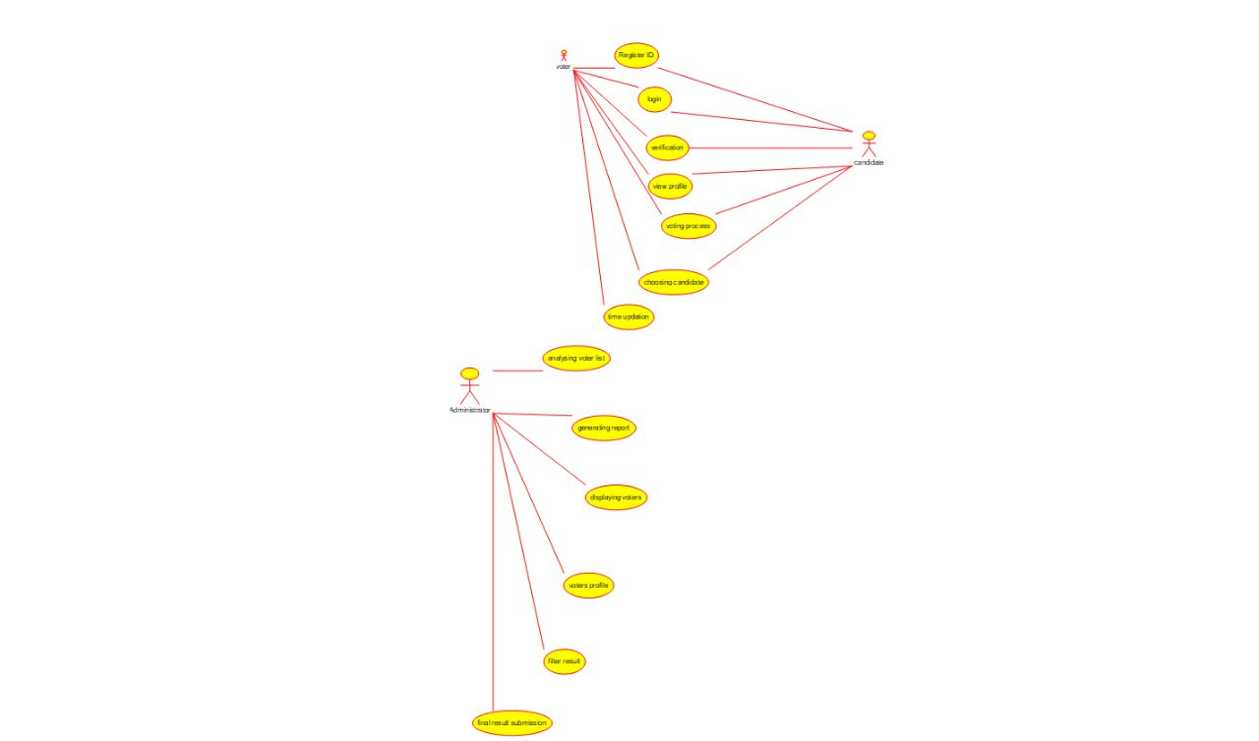

3.Draw and validate the flowchart to compute the quotient and remainder

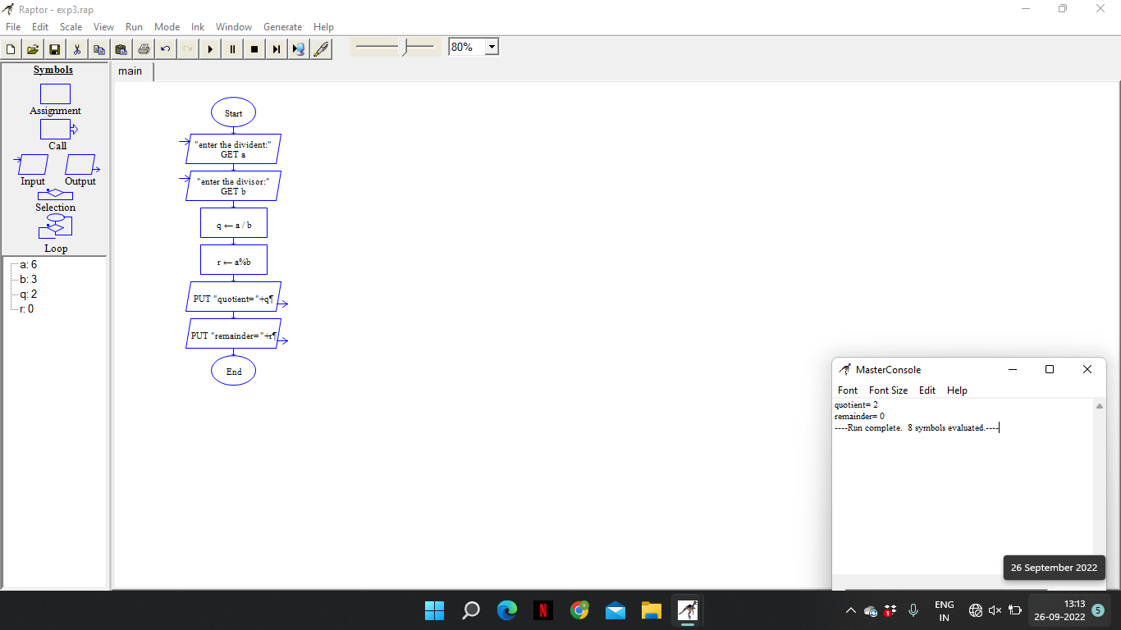

4. Draw a USE-CASE diagram for Online Shopping system using CASE tools

